**Project Management and Ideation**

**By Solomon Opio**

**0755510000**

Lead the Binary Garage

Your learning should enable you to solve “real problems “.

**Section1: Ideation Process /Session.**

1. **Team formation.**

As a project manager you should be able to hire people to do given tasks in your company without you having to do it your-self.

The best teams consist of:

* A hacker to focus on the product – Focuses on the technical staff and has a broad know-how and passion for ttechnology.
* A hustler to focus on the customer - Finds the right business model, sees trends and patterns and is a good networker.
* An artist to focus on design -constantly gets new ideas, understands how design affects user experience and observes with a truly open mind.

**Note**

1. Most people’s projects fail after Uni because they in most cases are not solving real world problems
2. We can panel beat our idea to make it plausible in the real world.

Criteria for design.

1. Human Centered design
   * Building a solution while working together with the end users. You need to understand what your end users are facing from the word go. Have a conversation that makes them feel at ease

**Section2: Project management**

* They do not necessarily need to be coding experts
* They organize their teams and assign them what to do and build not necessarily indulging in the process.

**The stages of Innovation and project construction.**

1.Understanding the **problem**.

2.Interact with the **Users**

3.What T**echnology** has to be used

4.Grow the **Idea** furnish it.

5.Build a **Prototype** that is functional.

6.**Validate the project.**

**7.Pitch the Idea**

:- The moment you start a solution of a problem you do not know, it’s like you are solving nothing.

:- You do not have to look for a job because you need to have a problem solving mindset. Observe an organization and have a solution to that problem and if you make the cut.” You get the job on YOUR TERMS.”

Notes

* You are to break down a problem into the main facts, figures, statistics, data points and background information -In terms of each of the above. What information do you hear about it?
* Consider environmental tech and business trends. Think of success stories or failures about the topic. Avoid things which can only be solved by the Government.

**PROBLEM SELECTION (IMPORTANCE AND FREQUENCY)**

**Stage1: Understanding**

Key Facts & Data

1. What are the main facts, figures, statistics, data points and background information.

Insights /Research

1. Consider environmental tech and business trends. Think of success stories or failures about the topic. (Avoid things which can only be solved by the Government.)

Ensure you understand your problem.

* 1. Read
  2. Research
  3. Analyze
  4. Discuss as a team

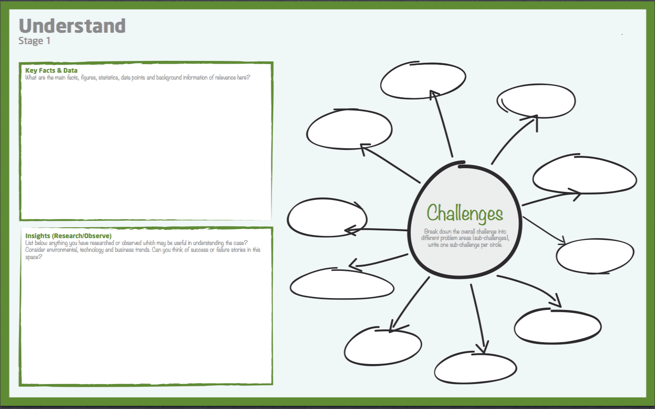

* + 1. It has to be part of the SDGs -Sustainable Development Goals.

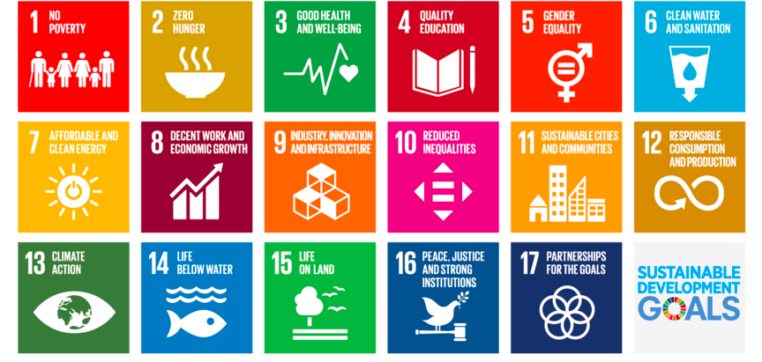

**KEY DEFINITIONS**

--- Importance – how important is it to the user group you are targeting

--- Frequency -How many people do you hear suffering from the issue and does it have a pain end result.

--- A pitch deck is like selling your idea to potential investors.

**Stage2: Users. Identify the users**

New insights about the user

1. Data points from expert interviews and online research.
2. List all your users’ problems (how, when, where)

You have to know the users. Attain this through

* 1. Identify
  2. Analyze
  3. Select
  4. Choose your segment
  5. Choose your challenge

You ought to describe the user in relation to the problem.

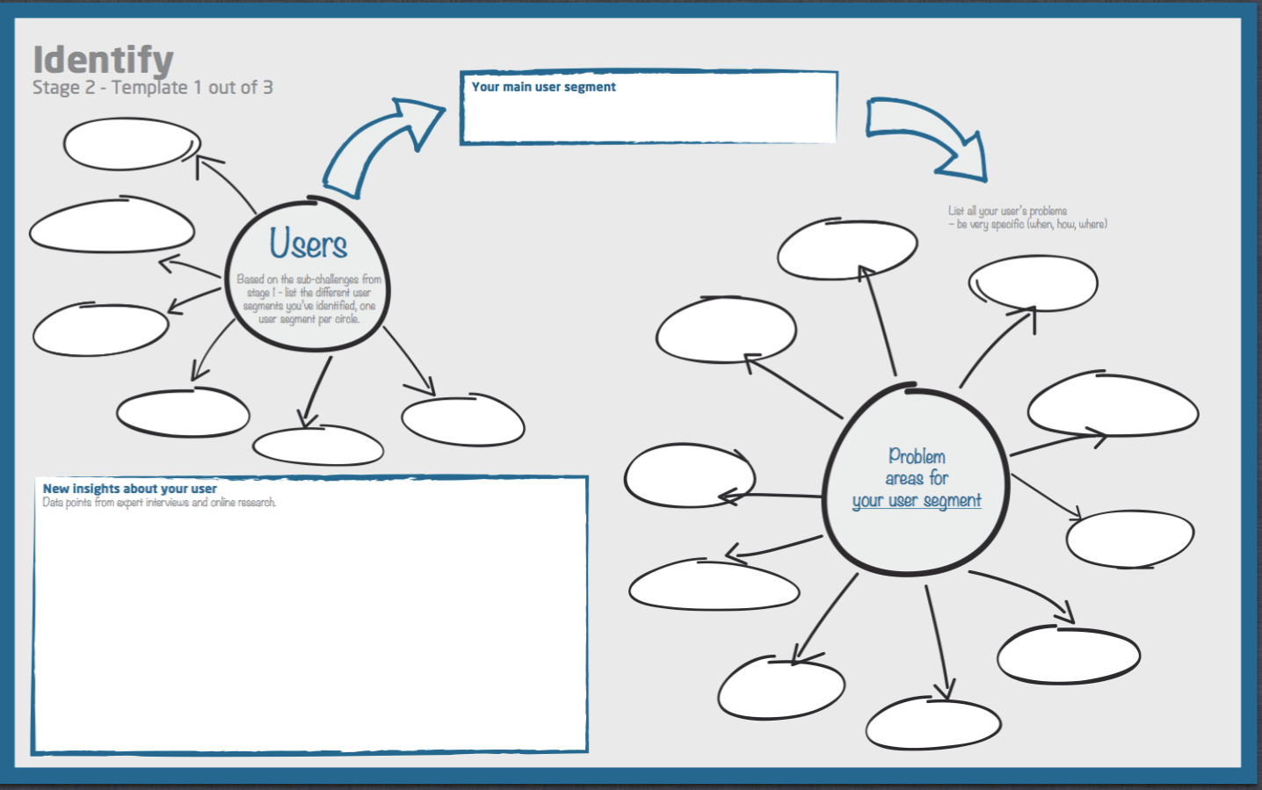

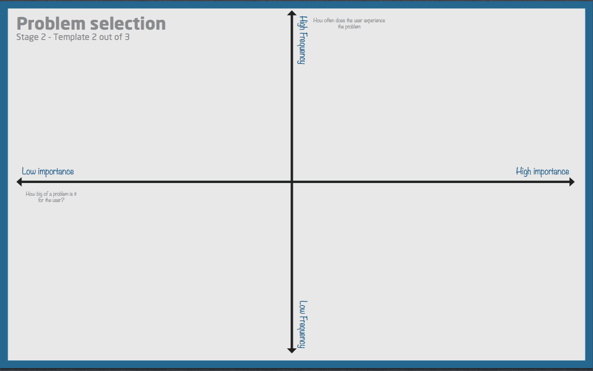

**Stage3: Problem and problem statement**

Problem

1. Give a quick description of the core problems and other related problems.

A problem statement is a statement that comes from what is happening, what is causing it to happen and what has it led to (pain).

**Stage4: Ideate.**

**IDEATION**

Stages here include:

1. Scope
2. Sort
3. Generate
4. Describe

**SCOPE**

Write down a very precise problem statement

**GENERATE**

Generate ideas

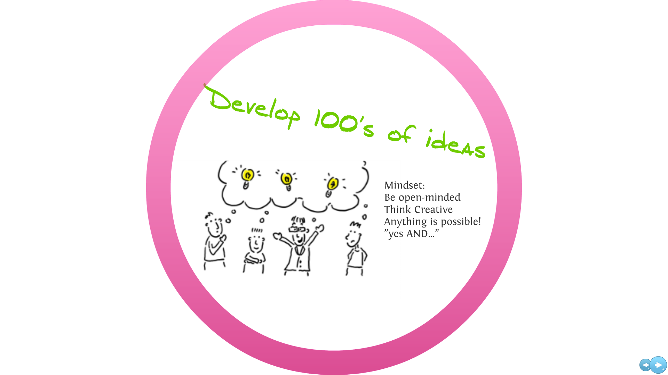

* The idea should be solving a plausible problem, not just an invention.
* Think about something that someone else has not thought about

**Rules of the Creative**

1. See opportunities and forget limitations
2. Generate as many ideas as possible. quantity over quality.
3. Do not criticize your friends. Criticism is not allowed
4. Co-create by building on each other’s ideas.

**“QTN: Assignment … write a problem statement on drug abuse today.”**

Stage1: Understanding the problem.

Stage2:Users and identity

Problem statement

Drug abuse continues to be a critical public health challenge, with over 70% of the population estimated to be affected by it in the age range of 12 to 24 years. and with 34.9% of the adolescent in Kampala affected.

This widespread impact exerts significant pain on individuals, families, and communities:

Drag abuse disorders often co-occur with mental health issues like depression complicating diagnosis and treatment

Drug abuse can affect the brain and behavior to the point where users cannot control their substance intake, even when aware of the harm involved.

The magnitude of these statistics highlights the urgency for multifaceted solutions.